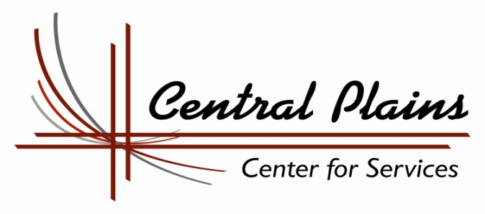

Education & Training Voucher Program - ETV

Central Plains Center for Services, through a contracted partnership with the Nebraska Department of Health and Human Services, administers the Education and Training Voucher (ETV) Program. This program provides financial assistance for tuition, fees and books, as well as one-on-one support, for current and former state wards to attend college.
Am I eligible?

Yes…if you have graduated from high school or obtained a GED and meet one of the following criteria:
- State or Tribal wards who are age 17 or older.
- Youth who were in the State or Tribe’s custody and received guardianship or adopted status at the age of 16 or older and have yet to reach age 21.
- Youth who were in the State or Tribe’s custody on their 17th birthday and are now between the ages of 17 and 21.
- Youth participating in the ETV Program on their 21st birthday, are eligible until they turn 23 years old, as long as they are enrolled in a post-secondary education or training program and are making satisfactory progress toward completion of that program.

  - Youth must be attending public or private four-year colleges or universities, two-year community colleges, vocational-technical schools or specialized non-profit trade schools as defined in the Higher Education Act of 1965.
How can ETV help me?

You can receive up to $3,000.00 per year (an individual shall not exceed the lesser of $3,000.00 per year or the total cost of attendance).

ETV funds can cover the following school related expenses:

- Tuition and Fees
- Books
- Application Fees

How do I apply?

You must complete an application and return it to us. You can get an application at:

- Website: www.central-plains.org
- Your local HHS Office
- By calling us at 308-872-6176
How do I know if I have been accepted into the ETV Program?
- Once your application is received at our office, our Youth Education Specialists, Andra White or Michele Taylor, will contact you by phone to review the application as well as review with you the services ETV will be able to provide.
- For questions please contact Central Plains Center for Services at (308) 872-6595 or by email at awhite@central-plains.org.

EDUCATION & TRAINING VOUCHER APPLICATION

Part A- Applicant Information

Today’s Date: _______________

Name: _________________________________________________________________________
Birth Date ________________________ Telephone # _________________________________
Current Address (both mailing and street) ____________________________________________
City ___________________________ State ___________________ Zip _________________
Email Address ___________________________________________________________
Date of dismissal from State’s Custody _______________ Age at time of dismissal _______

Or, if applicable: Date of expected dismissal from State’s Custody _____________________
Tribal Ct. Jurisdiction at time of dismissal (if applicable) __________Date of dismissal_____
Social Security # _______________________________________________________________

Desired date of college/school entrance? ___________________________________________

Required demographic information (current)
Age ____ Gender_____ Race/Ethnicity __________ Tribal Affiliation (if any) ____________
Special Needs, please specify _____________________________________________________
Married? Yes, _____ No,______ Are you a parent? Yes ______ No ______
If yes is the child living with you? Yes ___ No___; If not are you paying support? Yes__ No___
Are you employed? Yes ___ No____ If so, is it considered part time _____ or full time _____

A. PROTECTION AND SAFETY WORKER INFORMATION (IF APPLICABLE)
P&S Worker: ________________________ Phone (_____)_____________________________
Office Location (City) ____________________________________________________________
For PSW: Please indicate what the youth’s permanency and independent living plan is:
______________________________________________________________________________
PSW Signature: ________________________________________________________________

By signing this Education and Training Voucher Application, I authorize the school I am attending to release all requested information to Central Plains Center For Services. In addition, I agree to comply with my outlined Education Plan and verify that the information in this application is accurate.

Applicants Signature: ___________________________________________________________
Date: _________________________________________________________________________

Education and Training Voucher Application
Part B-Education and training Plan

The purpose of this plan is to ensure that your educational needs are met. It is very important that as a participating youth you are involved in developing and designing a plan that will assist in your transition to self-sufficiency as an adult.

The following are necessary steps for your eligibility for financial help through the Education Training Voucher Program. Please provide documentation of the completion of each step.

❑ Completed admission at chosen school

❑ Completed admission testing (if necessary)

❑ Completed the Free Application for Federal Student Aid (FAFSA) – FAFSA confirmation
letter attached

❑ Register for classes – Copy of class registration or schedule attached. This must include
the total tuition and fee charges and total number of credit hours registered

❑ Statement of book costs – This must include exact cost of books for your classes.
You may need to contact the campus bookstore for prices.

❑ Complete a minimum of 75% of classes and maintain at least a C (or 2.0) average.
A copy of your grade report must be submitted within 30 days of the completion of your classes.

To become a part of the Education Training Voucher Program, please submit the following:
- Part A – Application/Youth Information
- Part B – Completed Education Plan (along with necessary documents)
- Part C – Youth Budget

Please submit your application and necessary documents by fax, email or mail to:
Central Plains Center For Services
908 South E Street
Broken Bow, NE 68822
Email: centralplains6176@msn.com
Fax: (308) 872-6596
Phone: (308) 872-6176

Education Specialist Contact Information
Andra White Michele Taylor
908 South E Street 908 South E Street
Broken Bow, NE 68822 Broken Bow, NE 68822
Phone: 308 872-6595 Phone: 308 627-3998
Email: awhite@central-plains.org Email: mtaylor@central-plains.org

EDUCATION AND TRAINING VOUCHER PROGRAM

Part C- Youth Budget

Monthly Basic Living Education Budget

Needs Budget Per Session

Expenses Expenses

Rent Tuition

Utilities Fees

Deposits Books

Food Supplies

Transportation Testing

Child Care Tutor

Telephone Other

Other

TOTAL TOTAL

Income Income
Wages Federal Grant

Unearned Income Loans

Former Ward Scholarships

Other State Grant

TOTAL TOTAL

Income minus Expenses Income minus Expenses

Justification for Funds (How does this fulfill your education plans?)

